Nepal college of information technology

Unit Test

|  |  |  |
| --- | --- | --- |
| Level: Bachelor | Semester – Fall | Year : 2014 |
| Programme: IT | | Full Marks : 70 |
|  | | Pass Marks: 35 |
| Course: Electronic Circuits and Instrumentation | | Time : 2hrs. |

|  |
| --- |
| *Candidates are required to give their answers in their own words as far as practicable.* |
| *The figures in the margin indicate full marks.* |
| *Attempt all the questions.* |

2. a) Why cascading is necessary? Derive the expression for overall voltage gain of n-stage cascade amplifier. (8)

b) Explain the effect of bypass capacitor on the frequency response of an amplifier. (7)

2. a) Find the overall voltage gain of cascaded transistor amplifier as shown in figure below. Given re1=re2=25Ω and β1=β2=110. (8)

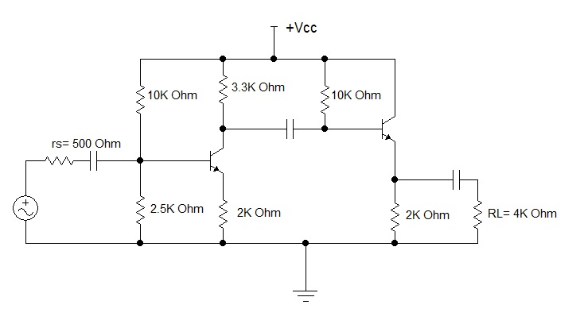

b) Draw Transformer Coupled load class A power amplifier and explain its operation. What are its main advantages? (7)

3. a) What do you mean by power amplifier? Differentiate between class A and class B power amplifier? (1+4)

b) Find the value of lower cut off frequency for the circuit given below.? For the give ckt Vcc=20 V RL= 4K ohm and rs=500 ohm .Given  = 100 neglect rc and re (5)

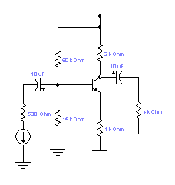

c) Define lower and upper cut off frequency. "Cut off frequencies are also called 3-dB frequency" justify it. (5)

4. a) The two transistors are cascaded where the unloaded voltage gain of 1st and 2nd stages are 24 dB and 20 dB respectively. The input resistance of 1st stage and 2nd stages are 8 K and 20 K respectively. Similarly the output resistances are 4 K and 2 K respectively. The 1st stage is driven by a source having resistance of 10 K and 20  load resistance is connected across the output terminal of 2nd stage. Find VL / VS. (5)

b) What is Distortion? What are the main types of Distortions (7)

c) While cascading, common base configuration cannot be used in intermediate stages although it has high voltage gain. Why? Explain. (3)

5. Write short notes on. (any two) (2×5=10)

a) Class AB power Amplifier

b) Half Power Frequencies

c) re model for common collector configuration